Unity Team
Matteo Dell’Oro, Alfio Giuliano Faro, Gabriel Logronio

STORYTELLING MATERIAL

Purpose | Document holding most of the storytelling components of the game
Creation date | 22-11-2017
Current owner | Matteo Dell’Oro
Last modification | 25-11-2017

Revision History
Who | When | What
Dell’Oro | 22-11-2017 | Created this document
Dell’Oro | 23-11-2017 | Added High Concept
Dell’Oro | 24-11-2017 | Added References to Periodic Table of Storytelling
Dell’Oro | 24-11-2017 | Added Synopsis
Logronio | 25-11-2017 | Added Theme

High Concept

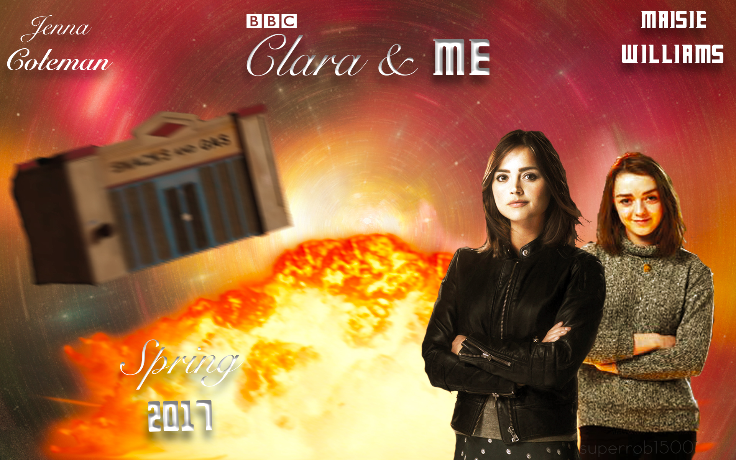 | Clara and the Doctor has parted ways. Together with Me, she takes on a journey through space and time in order to unravel a new mystery and bring order through the different timelines, while the shadow approaches.
In Doctor Who: Aftermath, take command of different characters with their diverse skill sets to make your way to distant worlds and unexplored times. Set up a party and go on a quest to investigate what’s happening in a huge factory, a murky mine or a frozen land: solve the mystery linked to unknown signal transmitters before it’s too late. | 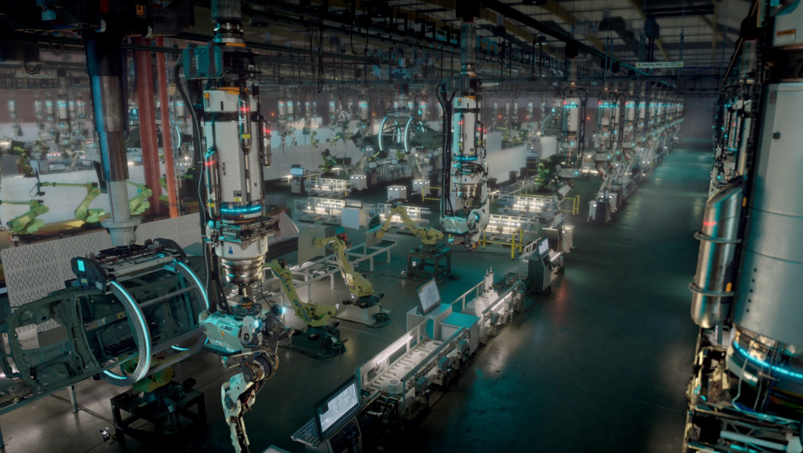
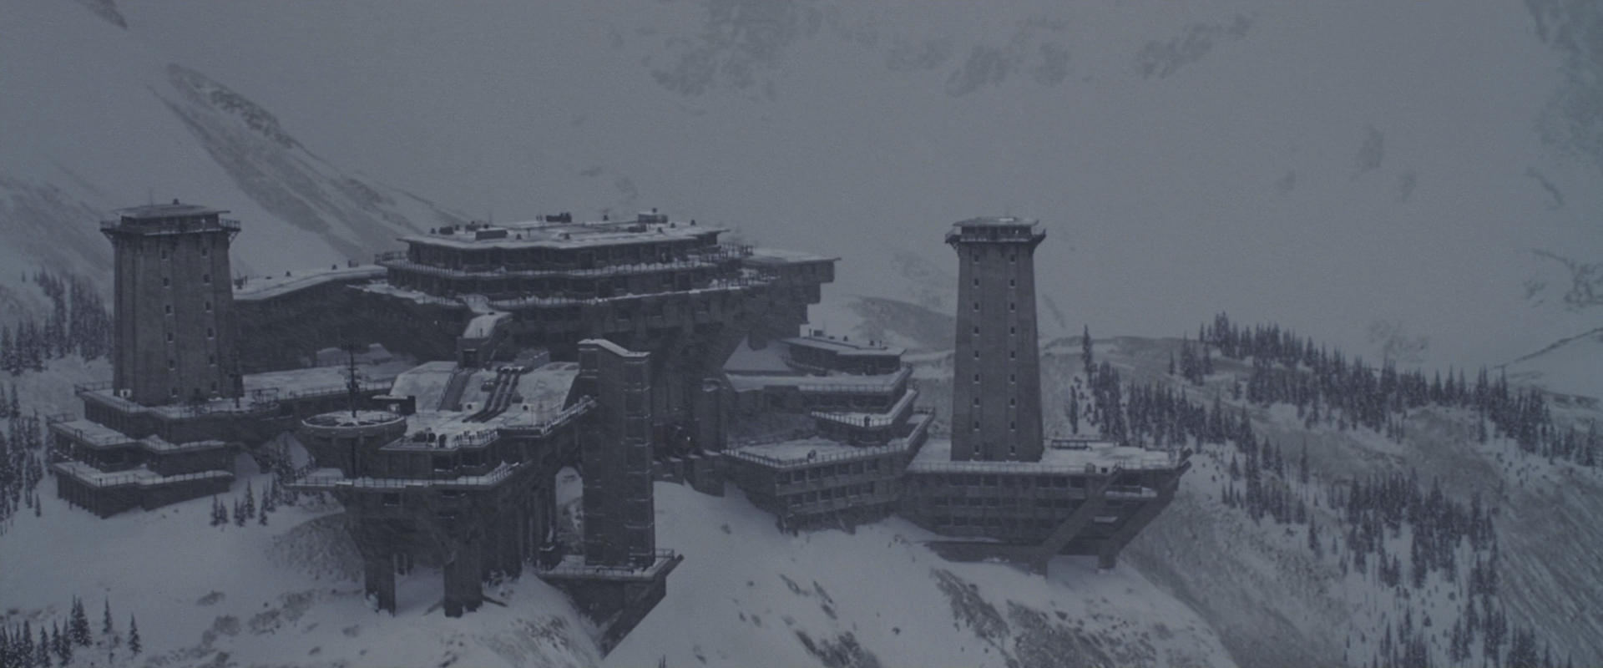 | Level up your heroes and equip them with new items and abilities to have an easier progression in the most difficult levels. Fight against scary bosses and monsters, explore every area, solve riddles and make sure to guarantee the survival of the universe.

Synopsis

We decided to outline the summary of the main choice of the player in the game. The game’s plot can be found in the “Story Document” of this very same folder.

Starting from right after the defeat of Strax, the player is going to be able to pick his party in the Tardis before diving into the missions. Clara an Me are the obligatory picks, and two characters can be chosen between: Captain Jack Harkness, Jenny the Doctor’s daughter, Alros the Silurian and Strax the Sontaran. Different picks will obviously lead to different dialogues (interchangeable one another, as the main characters – Clara and Ashildr – are going to be always in the party and can’t be opted out). Also gameplay wise having different heroes will impact the experience as shortcuts, strategies and items will only be available when a certain character is chosen before the level.

Another possible choice is made at the end of each of the four transmitter worlds: once the Doctor clones are dispatched, the player can choose whether to imprison or leave free the guardians, companions of the evil replicas. The choices will have an impact on how the story will end, as explicit in the Story Document.

Theme

As with every Doctor: Who media, the main theme is time travelling. Using the Tardis, the group is able to explore different timelines and different locations with virtually no travel time.

Another theme of the game is the hostile/friendly relationship with the different races of the Doctor: Who world, consisting in many such as Humans, Silurians, Sontarans and Zygons.

The game main objective is stopping the evil mind (Missy’s) trying to take possession of the free world and attempting to impose her control over the free will of the universe. The game events follow the struggle of the heroes in trying to stop this dangerous and apocalyptic plan and her thirst of vengeance.

References to the Periodic Table of Storytelling

Trope Name | Explanation within the story
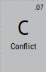 | The party of heroes against Missy.
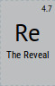 | How Missy is behind all the schemes.
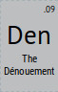 | Missy’s plan gets revealed step by step.
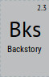 | The context of the Doctor Who Season 9 finale, “Hell Bent” is pretty key to get where the characters are coming from.
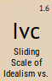 | Clara is the idealistic character in the scale, while Ashildr is the polar opposite being the cynic.
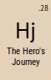 | The heroes journey through the whole game.
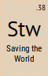 | The party effort to prevent Missy’s success.
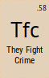 | Clara and Ashildr, even though from different backgrounds, fight together in order to reach a common goal (saving the world).
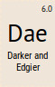 | The story gets progressively darker until the final parts.
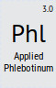 | Zeiton-7 is the material fuelling the plot, even without apparent a scientific explanation of its effects.
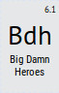 | How Jack saves the girls from the Zygon attack.
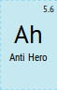 | Player choice: if the player decides to lock up the guardians, a trait heroes don’t usually have.
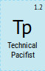 | Clara: she uses violence only if she has to and if she does she makes sure nobody gets killed doing so.
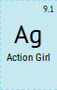 | Clara and Ashildr, both bad-asses and action-based female figures.
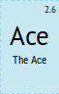 | Jack, a master in the art of fighting with guns, and highly respected among the group.
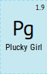 | Clara, a decisive female figure who never gives up.
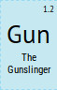 | Jack and Jenny, both very good at using weapons and guns.
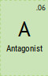 | Missy, the one main figure whose interests goes against the heroes party.
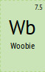 | Alros in the moment when he loses his younger brother.
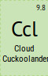 | Sam, a weird character with his own world and his own rules.
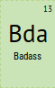 | Clara, Ashildr, Jack and Jenny, all characters with strong personalities and traits of skill, bravery and attitude.
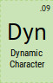 | Alros, evolving through the story with different layers (altruism, sadness, anger).
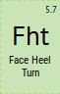 | Thought to be: the Doctor found on the future Earth, which eventually turns out to be a clone.
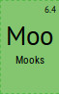 | Various enemies throughout the story, who just get defeated without too much difficulty by the heroes.
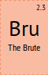 | War, the 9th Doctor clone.
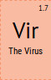 | Famine, the 10th Doctor clone.
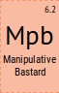 | Conquest, the 11th Doctor clone.
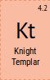 | Death, the 12th Doctor clone.
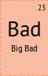 | Missy, the one big and final antagonist.
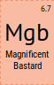 | Missy, being smarter than pretty much every other character, and doing it with style.
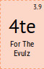 | Missy, being evil just “because she can”.
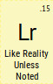 | Elements, items and places in the story are exactly the same as their counterparts in the real world, unless stated otherwise.
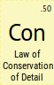 | The only details noted in the story are the ones important to the story itself, with everything else left out.

